Name of Testers:

1. Hrushikesh
2. Harshvardhan
3. Asha
4. Krishna
5. Manish
6. Anupam
7. Tahir

------------------------------------------------------------------------------------------------------------------------------

Objective

The objective of this document is to provide a detailed understanding of how Classic and Adaptive AUTOSAR platforms work together to implement a cruise control system in an automotive environment. The focus is on outlining the interactions between various software components, the communication mechanisms involved, and the overall workflow from sensor inputs to actuator outputs. This document aims to illustrate the seamless integration of high-level control strategies with real-time execution to achieve a reliable and efficient cruise control system.

Overview

Cruise control is a widely used automotive feature that maintains a vehicle's speed at a user-specified level without the need for continuous driver input. Modern advancements in automotive technology have led to the development of Adaptive Cruise Control (ACC), which extends traditional cruise control by dynamically adjusting the vehicle's speed to maintain a safe distance from other vehicles.

To implement such sophisticated control systems, the automotive industry relies on the AUTOSAR (AUTomotive Open System ARchitecture) standard, which provides a layered architecture to enhance software reuse, scalability, and interoperability across different vehicle platforms.

This document explores the integration of Classic and Adaptive AUTOSAR platforms in a cruise control system:

Classic AUTOSAR

Classic AUTOSAR is designed for real-time, safety-critical applications. It includes various Software Components (SWCs) that interact with hardware sensors and actuators to perform precise control tasks. In the context of cruise control, Classic AUTOSAR handles:

- Speed sensing and control

- Brake actuation

- Throttle actuation

Adaptive AUTOSAR

Adaptive AUTOSAR is designed for applications requiring high computational power, flexibility, and dynamic configuration. It manages advanced features and user interactions, such as:

- Receiving user commands (set speed, increase/decrease speed, resume, cancel)

- Processing environmental data (radar and camera inputs) for ACC

- High-level decision making and control strategies

Communication and Coordination

The integration of Classic and Adaptive AUTOSAR platforms is facilitated by the Port Adapter, which ensures smooth communication between the two platforms. This allows for the exchange of control commands and feedback data, enabling the cruise control system to operate seamlessly.

Workflow

The workflow of the cruise control system involves multiple stages:

1. Sensor Data Collection: Real-time data from speed sensors, accelerator and brake pedal position sensors, and radar/camera sensors are collected.

2. Processing and Control: Classic AUTOSAR SWCs process the sensor data to control the vehicle's speed, throttle, and braking in real-time. Adaptive AUTOSAR SWCs handle user commands and advanced ACC functionalities.

3. Communication: The Port Adapter facilitates communication between Classic and Adaptive platforms, ensuring coordinated control.

4. Execution: Actuators adjust the vehicle's speed and braking based on processed data and commands.

Workflow Explanation

1. Sensors and Inputs (Classic AUTOSAR)

- Speed Sensor: Monitors the vehicle's current speed.

- Accelerator Pedal Position Sensor: Detects the position of the accelerator pedal.

- Brake Pedal Position Sensor: Detects the position of the brake pedal.

2. Classic AUTOSAR Modules

- Speed Control SWC (Classic):

- Processes input from the speed sensor.

- Adjusts throttle position via actuator control.

- Brake Control SWC (Classic):

- Processes input from the brake pedal position sensor.

- Engages/disengages braking.

- Throttle Control SWC (Classic):

- Processes input from the accelerator pedal position sensor.

- Controls throttle position for maintaining speed.

3. Adaptive AUTOSAR Modules

- Cruise Control Manager SWC (Adaptive):

- Receives user commands (set speed, increase/decrease speed, resume, cancel) via HMI (Human-Machine Interface).

- Sends commands to Classic SWCs via Port Adapter.

- Advanced Features SWC (Adaptive):

- Handles additional functions like adaptive cruise control (ACC) which may involve radar or camera inputs.

- Processes complex algorithms for maintaining a safe distance from other vehicles.

4. Communication via Port Adapter

- The Port Adapter facilitates communication between Adaptive and Classic platforms, ensuring commands and data are exchanged seamlessly.

5. Execution and Feedback Loop

- Classic SWCs execute commands and adjust vehicle speed.

- Feedback from sensors is continuously processed to maintain the desired speed.

- Adaptive SWCs update and refine control strategies based on sensor data and user inputs.

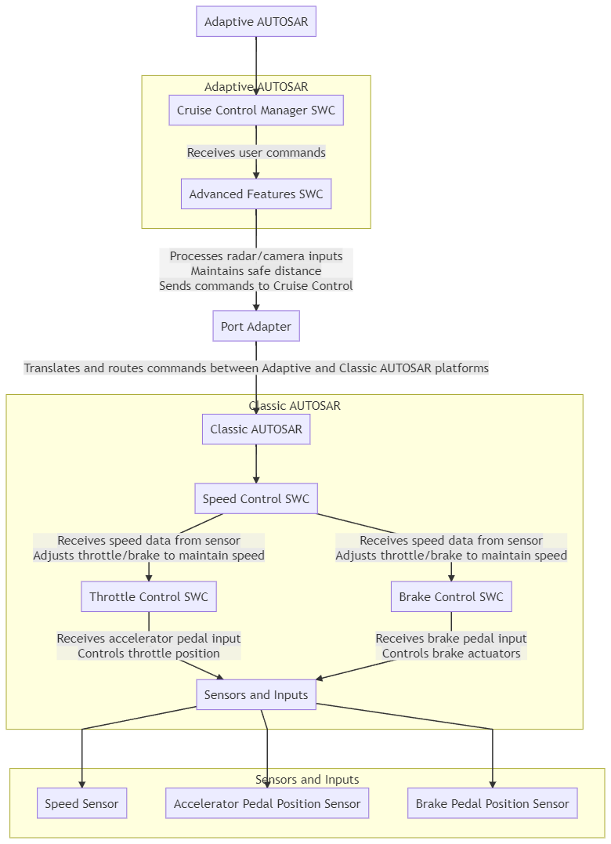

**Key Differences**

* **Architecture**: Classic AUTOSAR is more static and predefined, while Adaptive AUTOSAR allows dynamic configuration and service discovery.
* **Communication**: Classic AUTOSAR uses predefined communication mechanisms like CAN, while Adaptive AUTOSAR leverages service-oriented communication.
* **Flexibility**: Adaptive AUTOSAR provides greater flexibility for integrating advanced functionalities and adapting to runtime changes.

Summary

This workflow demonstrates how the Adaptive and Classic AUTOSAR platforms work together in a cruise control system. Adaptive AUTOSAR manages high-level control and user interface, while Classic AUTOSAR handles real-time, safety-critical control of vehicle speed and braking. The Port Adapter ensures seamless communication between the two platforms, integrating advanced features and real-time controls.

THANK YOU